The Sacramento Children’s Home eVIBE Program presents

NURTURING PARENTING PROGRAM

# *Guiding families in building nurturing relationships with self and their* children; empowering them to make good choices; and

*using positive intervention skills to effectively solve problems.*

The Nurturing Parenting Program focuses on managing conflict and serving culturally-diverse families with children in a one-on-one, in-home setting and/or group

setting in school sites, faith-based centers, and community settings.

This is a FREE, voluntary program for families with children ages newborn to 18.

Incentives, including snacks, raffle prizes, and gift cards, are offered as incentives for families to complete the program.

TOPICS INCLUDE:

* Positive communication
* Establishing routines for family activities
* Appropriate expectations & child development
* Effective age-appropriate discipline
* Building empathy & understand- ing the importance of self care
* Improving children’s self-worth

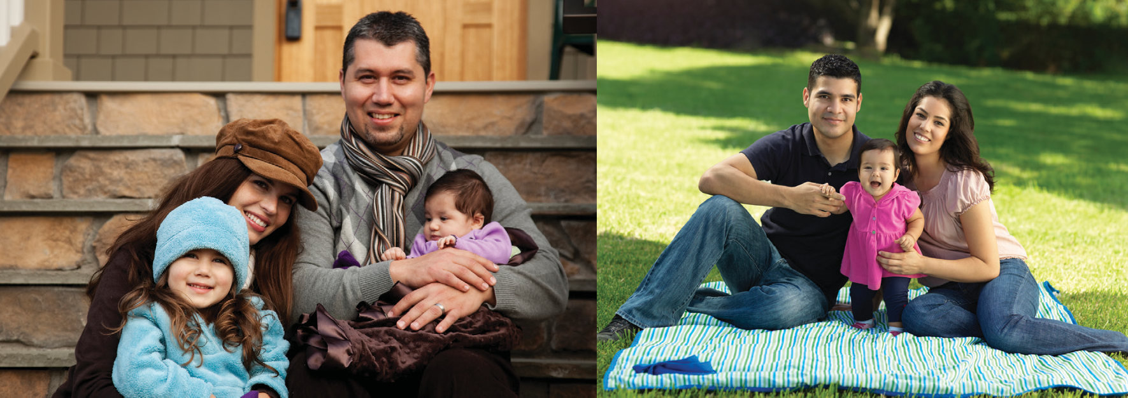

Pre-registration is required. For more information, or to sign up for the program in your community, please contact Gail Russell at (916) 452-3981 or via email at [Gail.Russell@kidshome.org.](mailto:Gail.Russell@kidshome.org)

*This program is funded by the Division of Behavioral Health Sciences through the voter-approved Proposition 63, Mental Health Services Act (MHSA).

